Christina Osorio, Mason Meiners, Lane Wenner

Technical Writing, October 17, 2013

**Winged Corkscrew Technical Description**

**1.0 Introduction**

A Winged Corkscrew is a device used to open bottles that are sealed with a cork. It has become very popular among household items since corks tend to be tightly embedded in glass bottles. A Winged Corkscrew consists of a metal spiral known as an auger, two wings, and a casing shown in Figure 1 below. The auger is twisted into the center of the cork and becomes tightly secured. By pressing down firmly on the wings of the corkscrew, the cork is pulled out. A Winged Corkscrew increases the efficiency of a typical corkscrew by allowing for the removal of the cork with minimal effort.

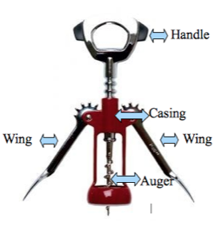

Figure 1: Parts of a Winged Corkscrew (modified from<http://corkwineonline.com/shop/ultimo-deluxe-wing-corkscrew-auger-worm/>)

**2.0** **Components**

The next three sections will give an in depth description of the auger, wing, and casing of the Winged Corkscrew.

**2.1 Auger**

The auger is divided into three subsections: the spiraled tip, the handle, and the shaft. By twisting the handle directly attached to the auger, the spiraled tip reaches the cork and begins to break through the top layer.

The spiraled tip is a screw-like metal coil with sharp edges and a piercing end. Immediately following the tip is a sharp screw-like spiral that wraps around the sides of the auger. These sharp edges allow the auger to easily continue breaking through the center of the cork. Once completely through, the auger remains firmly in place gripping the cork tightly in order for it to be pulled out. Below, Figure 2 shows the auger entering a cork, and Figure 3 shows the dimensions of the entire auger.

 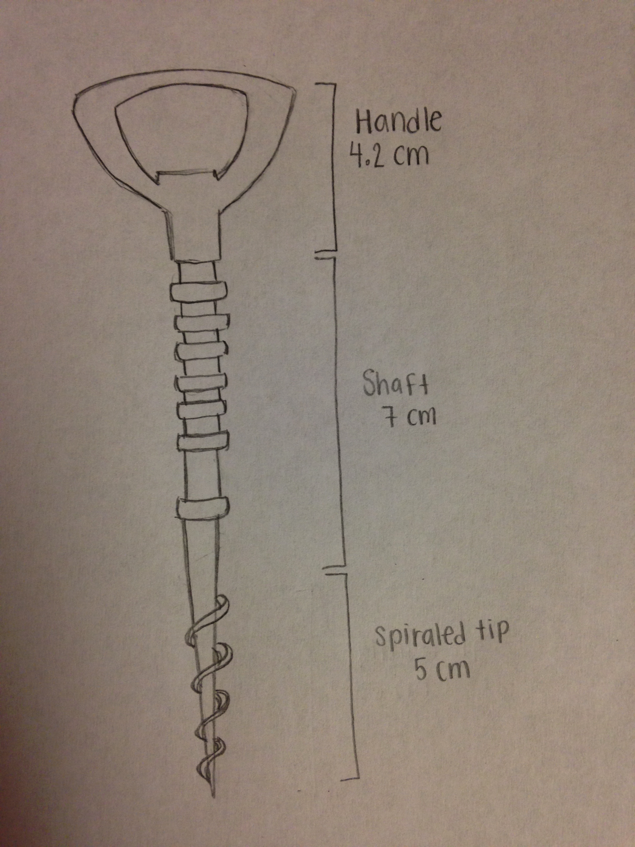

Figure 2: Auger entering cork (<http://i.telegraph.co.uk/multimedia/archive/01650/cork_1650076c.jpg>)

Figure 3: Drawing of entire auger with dimensions (Drawing Provided by Christina Osorio)

The handle is used to drive the spiraled tip into the cork through a twisting mechanism. The handle is shaped into a metal oval in order to easily allow the user to grasp and twist the handle. These handles are often made of steel, wood, or plastic.

Between the handle and the spiraled tip is the shaft. The shaft is comprised of a series of grooves and bumps that resemble the teeth of a gear. The shaft and wing work together to vertically move the entire auger.

**2.2 Wing**

The wing is a lever designed to interlock with the auger in order to move the auger vertically. Each identical wing, which is made out of a metallic alloy, is divided into two parts: the circular gear and tail. The circular gear of the wing interlocks with the teeth of the auger’s shaft. The tail of the wing is used as a lever to move the wing, which in turn moves the auger. When the user rotates the wing, the wing’s rotational motion translates to the linear motion of the auger due to the interlocking gears. Ultimately, the wings are used to pry the cork from the wine bottle by pressing downwards on the wings. The dimensions of the wing are provided in Figure 4.1. Figure 4.2 and 4.3 demonstrate before and after images of the rotation of the wings that led to vertical movement of the auger.

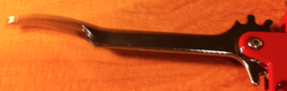

9.5 centimeters long

3 centimeters wide

Figure 4.1: The Wing (Picture Provided by Lane)

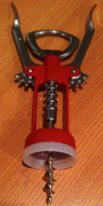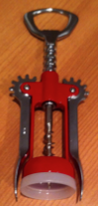

Figure 4.3: Winged Corkscrew with wings down (Picture provided by Lane)

Figure 4.2: Winged Corkscrew with wings up (Picture provided by Lane)

**2.3 Casing**

The third and final part of the Winged Corkscrew is the casing. The casing, made from a metallic alloy, is the body of the Winged Corkscrew that holds the device together. The auger slides through the cylindrical hole at the top and the two wings are attached on each side using small metal fasteners. The casing is depicted below in Figure 5.

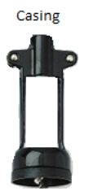

Figure 5: Picture of the casing (<http://www.personal.psu.edu/users/e/k/ekl5029/winged%20corkscrew.jpg>,

Edited by Christina Osorio)

The casing is designed to function with both the auger and wing. The auger can slide through the cylindrical hole located at the top of the casing. The handle stops this sliding process because its width is larger than the cylindrical hole. On each side near the top of the casing there is a drilled hole, which is used to mount the wings to the casing. Upon assembly, a metal fastener secures these aligned holes together to create a secure attachment between the two objects.

The bottom of the casing is a hollowed out cylindrical shape that is designed to fit over the top of the bottle that the user is opening. The cylindrical shape snugly fits over the top of a wine bottle to provide stability when driving the auger into the cork. The other purpose of this bottom is to act as the counter force on the bottle as the cork is being pulled upward. Therefore, unlike many other versions of the corkscrew, it is not necessary for the user to hold the bottle down when using the Winged Corkscrew.

**3.0 How to Use the Winged Corkscrew**

Step 1: Touch the spiraled tip of the auger to the cork as seen in Figure 6.1.

Step 2: Twist the auger handle clockwise until the auger is completely driven through the cork as seen in Figure 6.2.

Step 3: Press down on the wings to remove the cork as seen in Figure 6.3.

Step 4: Gently rock the Winged Corkscrew until the cork has been separated from the bottle as seen in Figure 6.4.

Figure 6.1 – 6.4: The process of opening a wine bottle using a Winged Corkscrew (fantes.com/manuals)

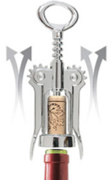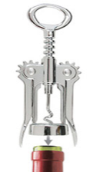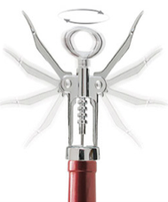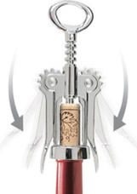

**4.0 Manufacture**

The Winged Corkscrew can be made of multiple materials, but plastic compounds and steel are among the most common. The auger is typically made of tempered low carbon steel or 440C stainless steel. The materials of choice for the wings are most commonly steel or a zinc alloy. The casing of the Winged Corkscrew is frequently a molded plastic due to its low cost. However, it can be made of steel or an alloy if it is an upscale Winged Corkscrew.

The auger can be made on a lathe, which means the raw material (usually cylindrical) is placed on a shaft, supported at one or both ends. It is then rotated so that the metal can be removed from the initial piece that is being worked on by pressing down with the cutting tool. As the material spins, shavings are peeled off and the auger takes its shape. The upper portion of the cylinder is not converted into a helix, but rather has notches carved out of it. These are the notches that allow the shaft of the auger to interact with the wing as gears would.

The wings are usually made by casting, which refers to using molds or dies to create the shape. This process is done by first heating up a material until it reaches its melting point. It is then poured into a mold and left to solidify so that it takes the shape of the mold. More intricate or complex pieces of metal are made this way because it produces a reliable and cost effective result.

The rivets that hold the wings to the case can be made in many ways. They can be made on a lathe, by blacksmithing, or through the use of a die. Given how small and simple they are, there are many creative ways to make them.

The casing is typically made of plastic that is heated up, injected into a mold, and left to harden. This process is simple and requires a die (or multiple dies for efficiency) in the shape of the casing, similar to how the wings are made. At this point in production, the manufacturer has the option to have their logo embossed on the casing.

**5.0 Conclusion**

The Winged Corkscrew is an improved, mechanized version of the original standard corkscrew and has become a necessity for most people. Since many liquids are packaged with a cork, most frequently wine bottles, there is no other simple way to open them. The Winged Corkscrew has been divided into three primary parts: the auger, the wings, and the casing. By adding the wings and mechanizing the device, minimal effort is needed to remove a cork from a bottle. This has become a very useful device that is likely to be found in kitchens and restaurants throughout the world.